|  |
| --- |
| Embedded Systems Lab Experiment 10 |
| Serial Peripherial Interface in ATmega 32 |
| To program two ATmega 32 microcontroller as a master and a slave for SPI communication between them to control a 7-segment display |

|  |
| --- |
| Jitbitan Baroi  3-31-2024 |

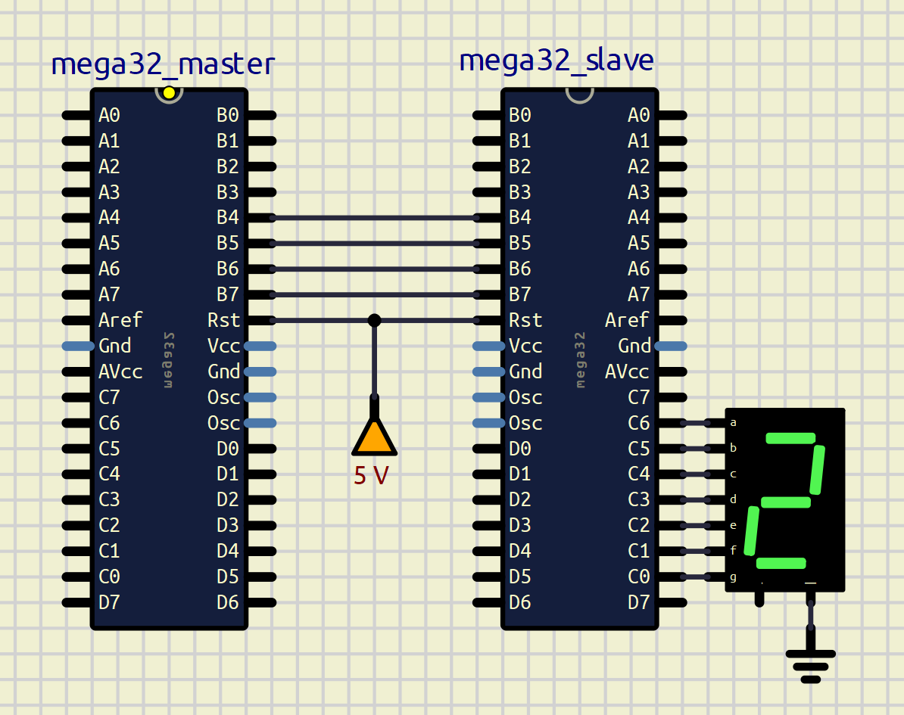

Schematic used for SPI Communication with master and slave boards mentioned